Class 11: Alpha Fold Pt. 2

Brittney Hayes

2024-02-13

Alphafold was run via GoogleColab at <https://colab.research.google.com/github/sokrypton/ColabFold>

We used AplhaFold2_mmseqs2 version.

The main outputs include a set of **PDB structure files** along with matching **JSON format files** that tell us how good the resulting models might be.

## Custom analysis of resulting models

Let’s start by loading the PDB structures in Mol*

library(bio3d)  
  
results_dir <-"HIVPrDimer_23119"  
  
# File names for all PDB models  
list.files(path ="HIVPrDimer_23119", pattern="*.pdb",  
 full.names = TRUE)

## [1] "HIVPrDimer_23119/HIVPrDimer_23119_unrelaxed_rank_001_alphafold2_multimer_v3_model_5_seed_000.pdb"  
## [2] "HIVPrDimer_23119/HIVPrDimer_23119_unrelaxed_rank_002_alphafold2_multimer_v3_model_1_seed_000.pdb"  
## [3] "HIVPrDimer_23119/HIVPrDimer_23119_unrelaxed_rank_003_alphafold2_multimer_v3_model_4_seed_000.pdb"  
## [4] "HIVPrDimer_23119/HIVPrDimer_23119_unrelaxed_rank_004_alphafold2_multimer_v3_model_2_seed_000.pdb"  
## [5] "HIVPrDimer_23119/HIVPrDimer_23119_unrelaxed_rank_005_alphafold2_multimer_v3_model_3_seed_000.pdb"

pdb_files <- list.files(path= "HIVPrDimer_23119",  
 pattern="*.pdb",  
 full.names = TRUE)  
  
# Print our PDB file names  
basename(pdb_files)

## [1] "HIVPrDimer_23119_unrelaxed_rank_001_alphafold2_multimer_v3_model_5_seed_000.pdb"  
## [2] "HIVPrDimer_23119_unrelaxed_rank_002_alphafold2_multimer_v3_model_1_seed_000.pdb"  
## [3] "HIVPrDimer_23119_unrelaxed_rank_003_alphafold2_multimer_v3_model_4_seed_000.pdb"  
## [4] "HIVPrDimer_23119_unrelaxed_rank_004_alphafold2_multimer_v3_model_2_seed_000.pdb"  
## [5] "HIVPrDimer_23119_unrelaxed_rank_005_alphafold2_multimer_v3_model_3_seed_000.pdb"

# Quick view of model sequences

library(bio3d)  
  
# Read all data from Models   
# and superpose/fit coords  
pdbs <- pdbaln(pdb_files, fit=TRUE, exefile="msa")

## Reading PDB files:  
## HIVPrDimer_23119/HIVPrDimer_23119_unrelaxed_rank_001_alphafold2_multimer_v3_model_5_seed_000.pdb  
## HIVPrDimer_23119/HIVPrDimer_23119_unrelaxed_rank_002_alphafold2_multimer_v3_model_1_seed_000.pdb  
## HIVPrDimer_23119/HIVPrDimer_23119_unrelaxed_rank_003_alphafold2_multimer_v3_model_4_seed_000.pdb  
## HIVPrDimer_23119/HIVPrDimer_23119_unrelaxed_rank_004_alphafold2_multimer_v3_model_2_seed_000.pdb  
## HIVPrDimer_23119/HIVPrDimer_23119_unrelaxed_rank_005_alphafold2_multimer_v3_model_3_seed_000.pdb  
## .....  
##   
## Extracting sequences  
##   
## pdb/seq: 1 name: HIVPrDimer_23119/HIVPrDimer_23119_unrelaxed_rank_001_alphafold2_multimer_v3_model_5_seed_000.pdb   
## pdb/seq: 2 name: HIVPrDimer_23119/HIVPrDimer_23119_unrelaxed_rank_002_alphafold2_multimer_v3_model_1_seed_000.pdb   
## pdb/seq: 3 name: HIVPrDimer_23119/HIVPrDimer_23119_unrelaxed_rank_003_alphafold2_multimer_v3_model_4_seed_000.pdb   
## pdb/seq: 4 name: HIVPrDimer_23119/HIVPrDimer_23119_unrelaxed_rank_004_alphafold2_multimer_v3_model_2_seed_000.pdb   
## pdb/seq: 5 name: HIVPrDimer_23119/HIVPrDimer_23119_unrelaxed_rank_005_alphafold2_multimer_v3_model_3_seed_000.pdb

pdbs

## 1 . . . . 50   
## [Truncated_Name:1]HIVPrDimer PQITLWQRPLVTIKIGGQLKEALLDTGADDTVLEEMSLPGRWKPKMIGGI  
## [Truncated_Name:2]HIVPrDimer PQITLWQRPLVTIKIGGQLKEALLDTGADDTVLEEMSLPGRWKPKMIGGI  
## [Truncated_Name:3]HIVPrDimer PQITLWQRPLVTIKIGGQLKEALLDTGADDTVLEEMSLPGRWKPKMIGGI  
## [Truncated_Name:4]HIVPrDimer PQITLWQRPLVTIKIGGQLKEALLDTGADDTVLEEMSLPGRWKPKMIGGI  
## [Truncated_Name:5]HIVPrDimer PQITLWQRPLVTIKIGGQLKEALLDTGADDTVLEEMSLPGRWKPKMIGGI  
## **************************************************   
## 1 . . . . 50   
##   
## 51 . . . . 100   
## [Truncated_Name:1]HIVPrDimer GGFIKVRQYDQILIEICGHKAIGTVLVGPTPVNIIGRNLLTQIGCTLNFP  
## [Truncated_Name:2]HIVPrDimer GGFIKVRQYDQILIEICGHKAIGTVLVGPTPVNIIGRNLLTQIGCTLNFP  
## [Truncated_Name:3]HIVPrDimer GGFIKVRQYDQILIEICGHKAIGTVLVGPTPVNIIGRNLLTQIGCTLNFP  
## [Truncated_Name:4]HIVPrDimer GGFIKVRQYDQILIEICGHKAIGTVLVGPTPVNIIGRNLLTQIGCTLNFP  
## [Truncated_Name:5]HIVPrDimer GGFIKVRQYDQILIEICGHKAIGTVLVGPTPVNIIGRNLLTQIGCTLNFP  
## **************************************************   
## 51 . . . . 100   
##   
## 101 . . . . 150   
## [Truncated_Name:1]HIVPrDimer QITLWQRPLVTIKIGGQLKEALLDTGADDTVLEEMSLPGRWKPKMIGGIG  
## [Truncated_Name:2]HIVPrDimer QITLWQRPLVTIKIGGQLKEALLDTGADDTVLEEMSLPGRWKPKMIGGIG  
## [Truncated_Name:3]HIVPrDimer QITLWQRPLVTIKIGGQLKEALLDTGADDTVLEEMSLPGRWKPKMIGGIG  
## [Truncated_Name:4]HIVPrDimer QITLWQRPLVTIKIGGQLKEALLDTGADDTVLEEMSLPGRWKPKMIGGIG  
## [Truncated_Name:5]HIVPrDimer QITLWQRPLVTIKIGGQLKEALLDTGADDTVLEEMSLPGRWKPKMIGGIG  
## **************************************************   
## 101 . . . . 150   
##   
## 151 . . . . 198   
## [Truncated_Name:1]HIVPrDimer GFIKVRQYDQILIEICGHKAIGTVLVGPTPVNIIGRNLLTQIGCTLNF  
## [Truncated_Name:2]HIVPrDimer GFIKVRQYDQILIEICGHKAIGTVLVGPTPVNIIGRNLLTQIGCTLNF  
## [Truncated_Name:3]HIVPrDimer GFIKVRQYDQILIEICGHKAIGTVLVGPTPVNIIGRNLLTQIGCTLNF  
## [Truncated_Name:4]HIVPrDimer GFIKVRQYDQILIEICGHKAIGTVLVGPTPVNIIGRNLLTQIGCTLNF  
## [Truncated_Name:5]HIVPrDimer GFIKVRQYDQILIEICGHKAIGTVLVGPTPVNIIGRNLLTQIGCTLNF  
## ************************************************   
## 151 . . . . 198   
##   
## Call:  
## pdbaln(files = pdb_files, fit = TRUE, exefile = "msa")  
##   
## Class:  
## pdbs, fasta  
##   
## Alignment dimensions:  
## 5 sequence rows; 198 position columns (198 non-gap, 0 gap)   
##   
## + attr: xyz, resno, b, chain, id, ali, resid, sse, call

# RMSD

rd <- rmsd(pdbs, fit=T)

## Warning in rmsd(pdbs, fit = T): No indices provided, using the 198 non NA positions

range(rd)

## [1] 0.000 14.507

# Draw a heatmap of these RMSD matrix values

library(pheatmap)  
  
colnames(rd) <- paste0("m",1:5)  
rownames(rd) <- paste0("m",1:5)  
pheatmap(rd)

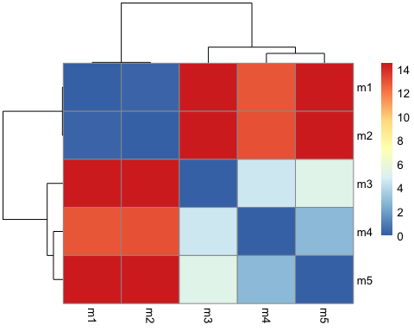

# Plot the pLDDT values across all models

# Read a reference PDB structure  
pdb <- read.pdb("1hsg")

## Note: Accessing on-line PDB file

plotb3(pdbs$b[1,], typ="l", lwd=2, sse=pdb)  
points(pdbs$b[2,], typ="l", col="red")  
points(pdbs$b[3,], typ="l", col="blue")  
points(pdbs$b[4,], typ="l", col="darkgreen")  
points(pdbs$b[5,], typ="l", col="orange")  
abline(v=100, col="gray")

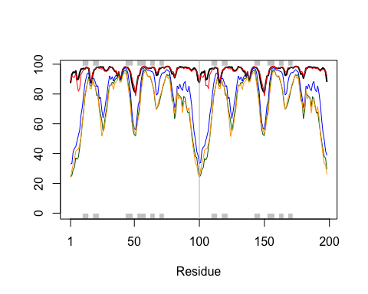

# Improve the superposition/fitting of our models by finding the most consistent “rigid core”

core <- core.find(pdbs)

## core size 197 of 198 vol = 5017.583   
## core size 196 of 198 vol = 4299.462   
## core size 195 of 198 vol = 4030.786   
## core size 194 of 198 vol = 3797.241   
## core size 193 of 198 vol = 3567.126   
## core size 192 of 198 vol = 3378.469   
## core size 191 of 198 vol = 3249.342   
## core size 190 of 198 vol = 3149.254   
## core size 189 of 198 vol = 3070.29   
## core size 188 of 198 vol = 2993.999   
## core size 187 of 198 vol = 2917.618   
## core size 186 of 198 vol = 2865.321   
## core size 185 of 198 vol = 2835.031   
## core size 184 of 198 vol = 2825.584   
## core size 183 of 198 vol = 2833.979   
## core size 182 of 198 vol = 2894.691   
## core size 181 of 198 vol = 2975.843   
## core size 180 of 198 vol = 3026.495   
## core size 179 of 198 vol = 3070.895   
## core size 178 of 198 vol = 3121.204   
## core size 177 of 198 vol = 3127.656   
## core size 176 of 198 vol = 3102.311   
## core size 175 of 198 vol = 3060.45   
## core size 174 of 198 vol = 2993.84   
## core size 173 of 198 vol = 2902.747   
## core size 172 of 198 vol = 2841.824   
## core size 171 of 198 vol = 2771.39   
## core size 170 of 198 vol = 2708.164   
## core size 169 of 198 vol = 2616.115   
## core size 168 of 198 vol = 2540.663   
## core size 167 of 198 vol = 2471.823   
## core size 166 of 198 vol = 2396.567   
## core size 165 of 198 vol = 2324.756   
## core size 164 of 198 vol = 2258.532   
## core size 163 of 198 vol = 2189.811   
## core size 162 of 198 vol = 2118.531   
## core size 161 of 198 vol = 2048.541   
## core size 160 of 198 vol = 1964.22   
## core size 159 of 198 vol = 1878.019   
## core size 158 of 198 vol = 1802.026   
## core size 157 of 198 vol = 1719.543   
## core size 156 of 198 vol = 1640.479   
## core size 155 of 198 vol = 1561.746   
## core size 154 of 198 vol = 1490.107   
## core size 153 of 198 vol = 1416.211   
## core size 152 of 198 vol = 1345.494   
## core size 151 of 198 vol = 1287.606   
## core size 150 of 198 vol = 1225.523   
## core size 149 of 198 vol = 1168.6   
## core size 148 of 198 vol = 1123.809   
## core size 147 of 198 vol = 1069.607   
## core size 146 of 198 vol = 1028.33   
## core size 145 of 198 vol = 986.295   
## core size 144 of 198 vol = 947.191   
## core size 143 of 198 vol = 910.624   
## core size 142 of 198 vol = 868.922   
## core size 141 of 198 vol = 829.982   
## core size 140 of 198 vol = 788.548   
## core size 139 of 198 vol = 749.234   
## core size 138 of 198 vol = 713.554   
## core size 137 of 198 vol = 679.035   
## core size 136 of 198 vol = 639.012   
## core size 135 of 198 vol = 599.236   
## core size 134 of 198 vol = 556.226   
## core size 133 of 198 vol = 521.307   
## core size 132 of 198 vol = 484.526   
## core size 131 of 198 vol = 453.614   
## core size 130 of 198 vol = 422.947   
## core size 129 of 198 vol = 404.641   
## core size 128 of 198 vol = 397.064   
## core size 127 of 198 vol = 371.629   
## core size 126 of 198 vol = 355.609   
## core size 125 of 198 vol = 334.859   
## core size 124 of 198 vol = 313.691   
## core size 123 of 198 vol = 291.489   
## core size 122 of 198 vol = 268.734   
## core size 121 of 198 vol = 245.865   
## core size 120 of 198 vol = 236.559   
## core size 119 of 198 vol = 218.641   
## core size 118 of 198 vol = 201.313   
## core size 117 of 198 vol = 183.861   
## core size 116 of 198 vol = 167.249   
## core size 115 of 198 vol = 151.276   
## core size 114 of 198 vol = 137.843   
## core size 113 of 198 vol = 124.983   
## core size 112 of 198 vol = 112.07   
## core size 111 of 198 vol = 101.394   
## core size 110 of 198 vol = 91.994   
## core size 109 of 198 vol = 82.201   
## core size 108 of 198 vol = 74.644   
## core size 107 of 198 vol = 70.256   
## core size 106 of 198 vol = 64.859   
## core size 105 of 198 vol = 58.745   
## core size 104 of 198 vol = 54.966   
## core size 103 of 198 vol = 49.885   
## core size 102 of 198 vol = 45.389   
## core size 101 of 198 vol = 41.648   
## core size 100 of 198 vol = 38.714   
## core size 99 of 198 vol = 36.289   
## core size 98 of 198 vol = 33.698   
## core size 97 of 198 vol = 28.156   
## core size 96 of 198 vol = 23.583   
## core size 95 of 198 vol = 19.899   
## core size 94 of 198 vol = 16.637   
## core size 93 of 198 vol = 12.448   
## core size 92 of 198 vol = 9.42   
## core size 91 of 198 vol = 8.296   
## core size 90 of 198 vol = 5.783   
## core size 89 of 198 vol = 4.006   
## core size 88 of 198 vol = 2.903   
## core size 87 of 198 vol = 2.24   
## core size 86 of 198 vol = 1.765   
## core size 85 of 198 vol = 1.408   
## core size 84 of 198 vol = 1.164   
## core size 83 of 198 vol = 0.969   
## core size 82 of 198 vol = 0.833   
## core size 81 of 198 vol = 0.675   
## core size 80 of 198 vol = 0.579   
## core size 79 of 198 vol = 0.529   
## core size 78 of 198 vol = 0.456   
## FINISHED: Min vol ( 0.5 ) reached

# Use the identified core atom positions as a basis for a more suitable superposition and write out the fitted structures

core.inds <- print(core, vol=0.5)

## # 79 positions (cumulative volume <= 0.5 Angstrom^3)   
## start end length  
## 1 10 24 15  
## 2 27 48 22  
## 3 53 94 42

xyz <- pdbfit(pdbs, core.inds, outpath="corefit_structures")

# Examine the RMSF between positions of the structure

rf <- rmsf(xyz)  
  
plotb3(rf, sse=pdb)  
abline(v=100, col="gray", ylab="RMSF")

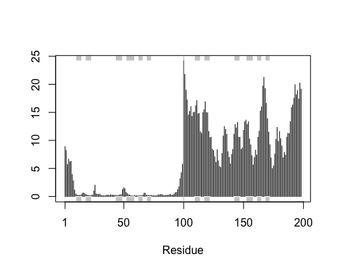

## Predicted Alignment Error for domains

library(jsonlite)  
  
# Listing of all PAE JSON files  
pae_files <- list.files(path=results_dir,  
 pattern=".*model.*\\.json",  
 full.names = TRUE)

# For example purposes lets read the 1st and 5th files

pae1 <- read_json(pae_files[1],simplifyVector = TRUE)  
pae5 <- read_json(pae_files[5],simplifyVector = TRUE)  
  
attributes(pae1)

## $names  
## [1] "plddt" "max_pae" "pae" "ptm" "iptm"

# Per-residue pLDDT scores   
# same as B-factor of PDB..  
head(pae1$plddt)

## [1] 87.69 93.19 94.69 94.38 95.50 89.56

# Checking other PAE values

pae1$max_pae

## [1] 15.89844

pae5$max_pae

## [1] 29.25

#Plot the N by N (where N is the number of residues) PAE scores with ggplot or with functions from the Bio3D package

plot.dmat(pae1$pae,   
 xlab="Residue Position (i)",  
 ylab="Residue Position (j)")

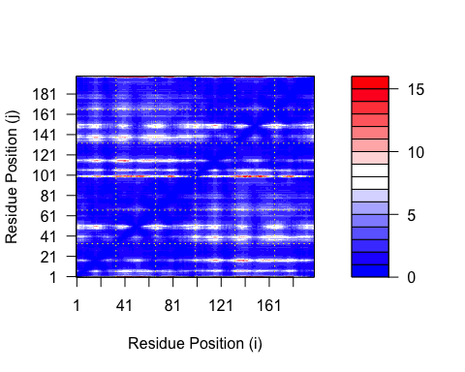

plot.dmat(pae5$pae,   
 xlab="Residue Position (i)",  
 ylab="Residue Position (j)",  
 grid.col = "black",  
 zlim=c(0,30))

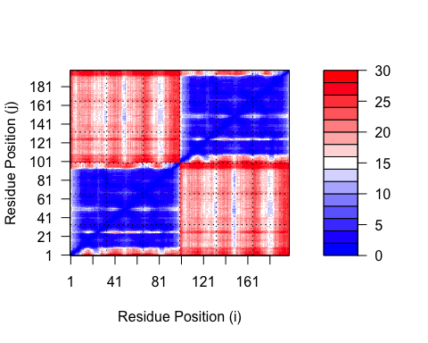

# Plot all of these using the same z range

plot.dmat(pae1$pae,   
 xlab="Residue Position (i)",  
 ylab="Residue Position (j)",  
 grid.col = "black",  
 zlim=c(0,30))

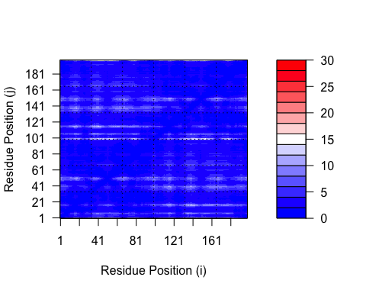

## Residue conservation from alignment file

aln_file <- list.files(path=results_dir,  
 pattern=".a3m$",  
 full.names = TRUE)  
aln_file

## [1] "HIVPrDimer_23119/HIVPrDimer_23119.a3m"

aln <- read.fasta(aln_file[1], to.upper = TRUE)

## [1] " ** Duplicated sequence id's: 101 **"  
## [2] " ** Duplicated sequence id's: 101 **"

# How many sequences are in this alignment

dim(aln$ali)

## [1] 5378 132

We can score residue conservation in the alignment with the conserv() function.

sim <- conserv(aln)  
  
plotb3(sim[1:99], sse=trim.pdb(pdb, chain="A"),  
 ylab="Conservation Score")

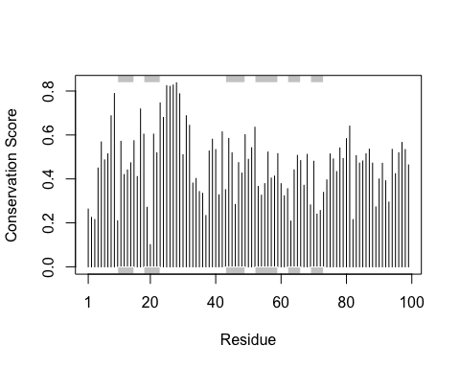

# Generate a consensus sequence with a high cutoff value

con <- consensus(aln, cutoff = 0.9)  
con$seq

## [1] "-" "-" "-" "-" "-" "-" "-" "-" "-" "-" "-" "-" "-" "-" "-" "-" "-" "-"  
## [19] "-" "-" "-" "-" "-" "-" "D" "T" "G" "A" "-" "-" "-" "-" "-" "-" "-" "-"  
## [37] "-" "-" "-" "-" "-" "-" "-" "-" "-" "-" "-" "-" "-" "-" "-" "-" "-" "-"  
## [55] "-" "-" "-" "-" "-" "-" "-" "-" "-" "-" "-" "-" "-" "-" "-" "-" "-" "-"  
## [73] "-" "-" "-" "-" "-" "-" "-" "-" "-" "-" "-" "-" "-" "-" "-" "-" "-" "-"  
## [91] "-" "-" "-" "-" "-" "-" "-" "-" "-" "-" "-" "-" "-" "-" "-" "-" "-" "-"  
## [109] "-" "-" "-" "-" "-" "-" "-" "-" "-" "-" "-" "-" "-" "-" "-" "-" "-" "-"  
## [127] "-" "-" "-" "-" "-" "-"

# Map this conservation score to the Occupancy column of a PDB file for viewing in molecular viewer programs

m1.pdb <- read.pdb(pdb_files[1])  
occ <- vec2resno(c(sim[1:99], sim[1:99]), m1.pdb$atom$resno)  
write.pdb(m1.pdb, o=occ, file="m1_conserv.pdb")